Kids Club Southport’s





SUMMER CLUB at HOLY TRINITY



Come and join us for 4 weeks of fun activities from

24th July to 20th August!

This year our schedule will include:

A Performance of Rumpelstiltskin by Altru Drama, Liverpool

Growing Seeds & Food preparation courtesy of Asda Southport





Roller Blading at the YMCA

Visits to Hesketh Park

This club is HAF funded for 16 days from 20th July to 14th August by Sefton Council. Free half-day places are available (from 9 till 1 or 1 till 5) for children on benefits-related free school meals. Please contact Sue on

07951 540919 for more information.

Your child will need to be registered on Magic Booking

(visit: kidsclubsouthport.co.uk and choose ‘enrolment.’)

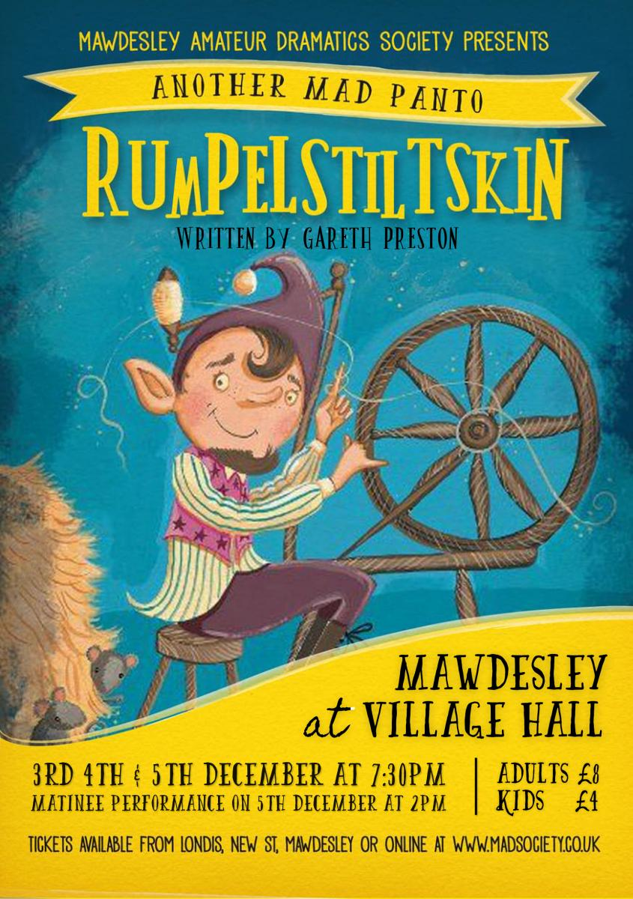

Please note that it is current practice

for all HAF applications to be checked.

by Sefton Council prior to attending.

