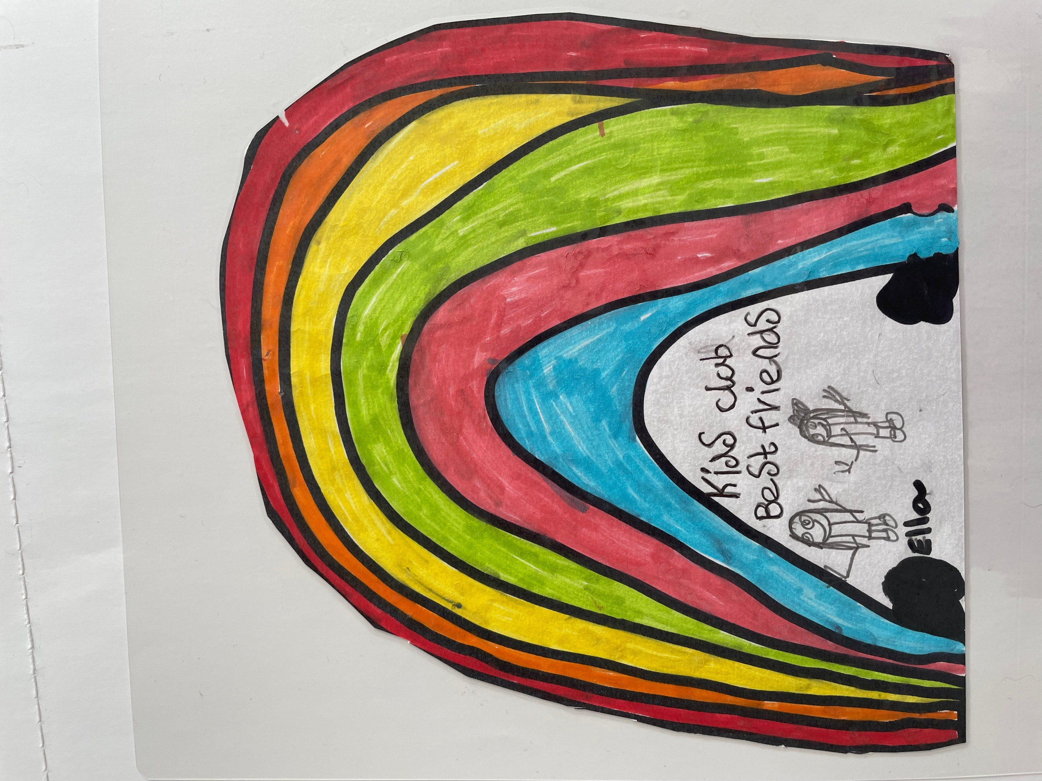

KIDS CLUB SOUTHPORT

Wrap Around Care & Holiday Clubs

**SUMMER CLUB LUNCH/TEA MENU**

**WEEK BEG.5th AUGUST 24**

**MONDAY**

SUE’S MEAT BALLS & SPAGHETTI

CRUSTY BREAD

YOGHURT & SHORTBREAD FINGER

**TUESDAY**

PASTA WITH TOMATO SAUCE & VARIOUS FILLINGS

GARLIC BREAD

STRAWBERRIES & ICE CREAM

**WEDNESDAY**

CHICKEN DIPPERS & HASH BROWNS

PIECE OF FRUIT & MINI ROLL

**THURSDAY**

WRAPS WITH VARIOUS FILLINGS

TORTILLA CHIPS & VEGGIE STICKS

YOGHURT & SPONGE CAKE

**FRIDAY**

FISH FINGERS AND SMILEY FACES

PEAS & SWEETCORN

MIVI ICE CREAM