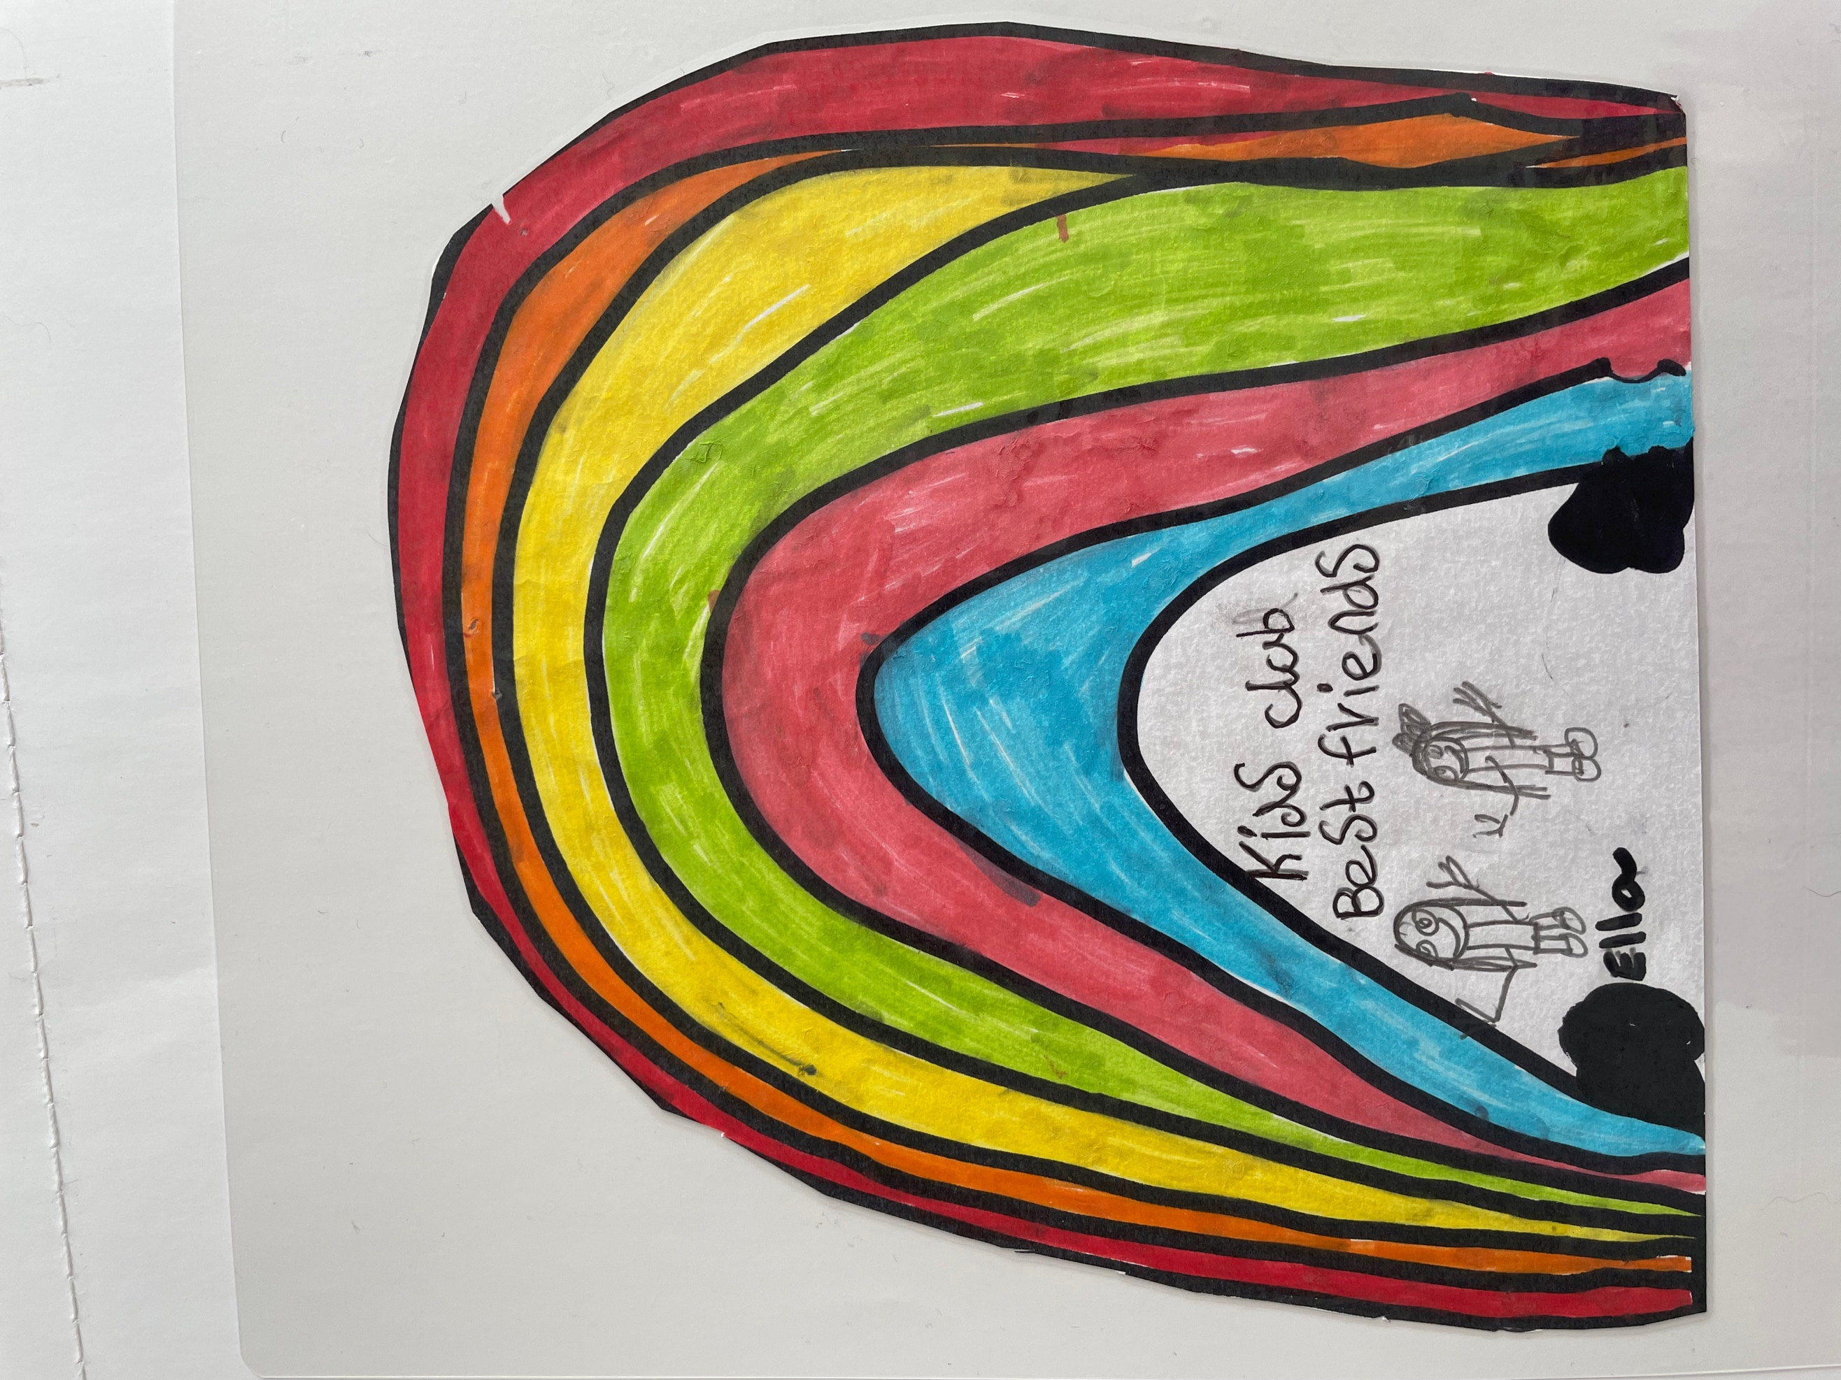

KIDS CLUB SOUTHPORT

Wrap Around Care & Holiday Clubs

**SUMMER CLUB LUNCH/TEA MENU**

**WEEK BEG.29th JULY 24**

**MONDAY**

SAUSAGE, POTATO WAFFLE & BEANS

YOGHURT & FLAPJACK

**TUESDAY**

CHEESE & TOMATO PIZZA SLICE

SMILEY FACES & SWEETCORN

MINI MUFFIN & FRUIT

**WEDNESDAY**

PASTA WITH TOMATO SAUCE & VARIOUS TOPPINGS

GARLIC BREAD

COOKIE & A PIECE OF FRUIT

**THURSDAY**

CHICKEN GOUJONS & FLAVOURED RICE

CRISPY CUBED POTATOS

SCOOP OF ICE CREAM

**FRIDAY**

BURGER IN A BUN WITH FRENCH FRIES

VEGGIE STICKS & DIPS

YOGHURT & ALMOND FINGER