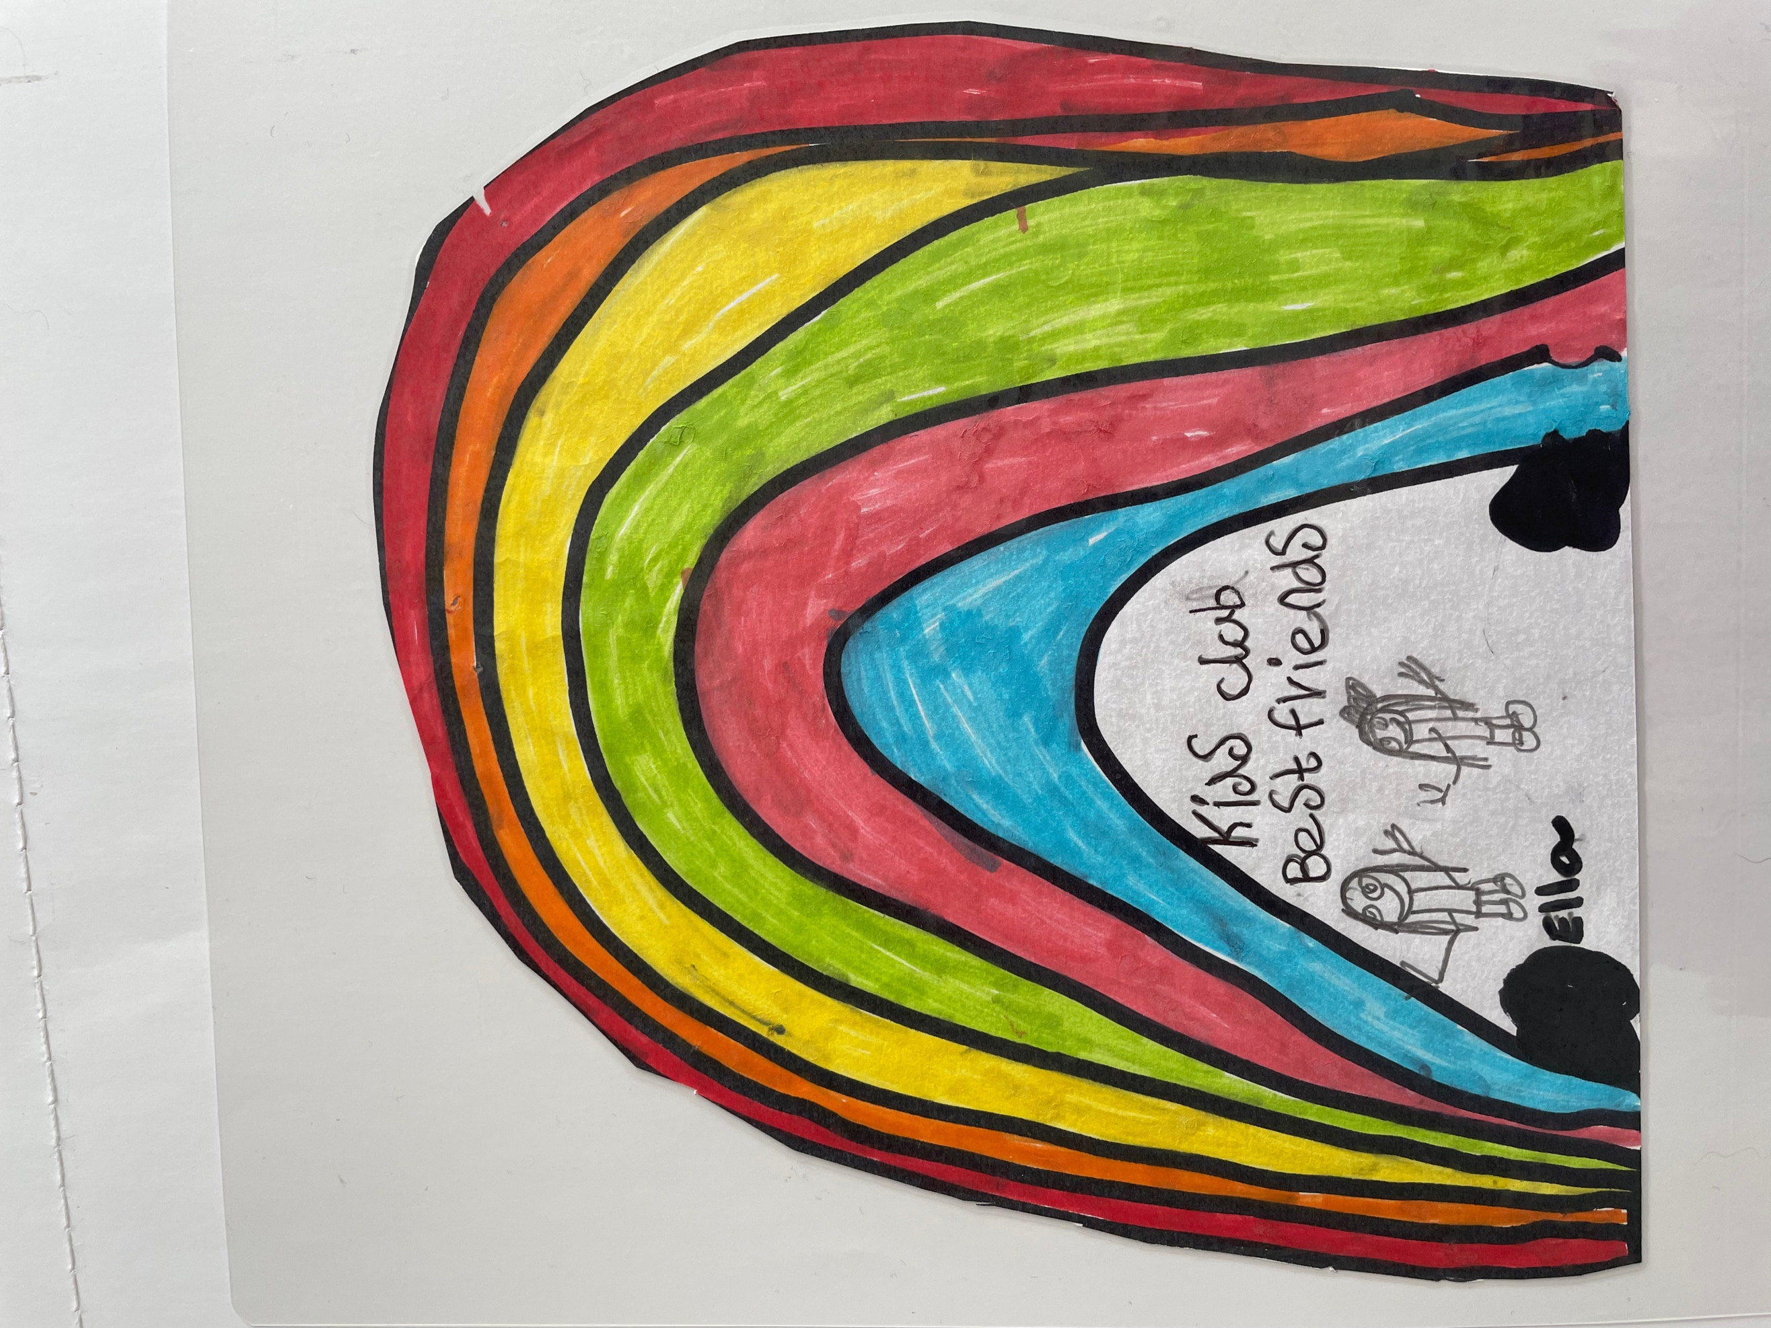

KIDS CLUB SOUTHPORT

Wrap Around Care & Holiday Clubs

**SUMMER CLUB LUNCH/TEA MENU**

**WEEK BEG.22nd JULY 24**

**MONDAY**

**TUESDAY**

**WEDNESDAY**

HOT DOG IN A BUN

POTATO STARS & VEGGIE STICKS WITH DIP

YOGHURT & ALMOND FINGER

**THURSDAY**

PASTA WITH TOMATO SAUCE & VARIOUS TOPPINGS

GARLIC BREAD

FLAPJACK & A PIECE OF FRUIT

**FRIDAY**

WRAPS WITH VARIOUS FILLINGS

VEGGIE STICKS & DIPS

TORTILLA CHIPS

ICE CREAM CONE