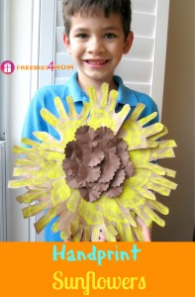

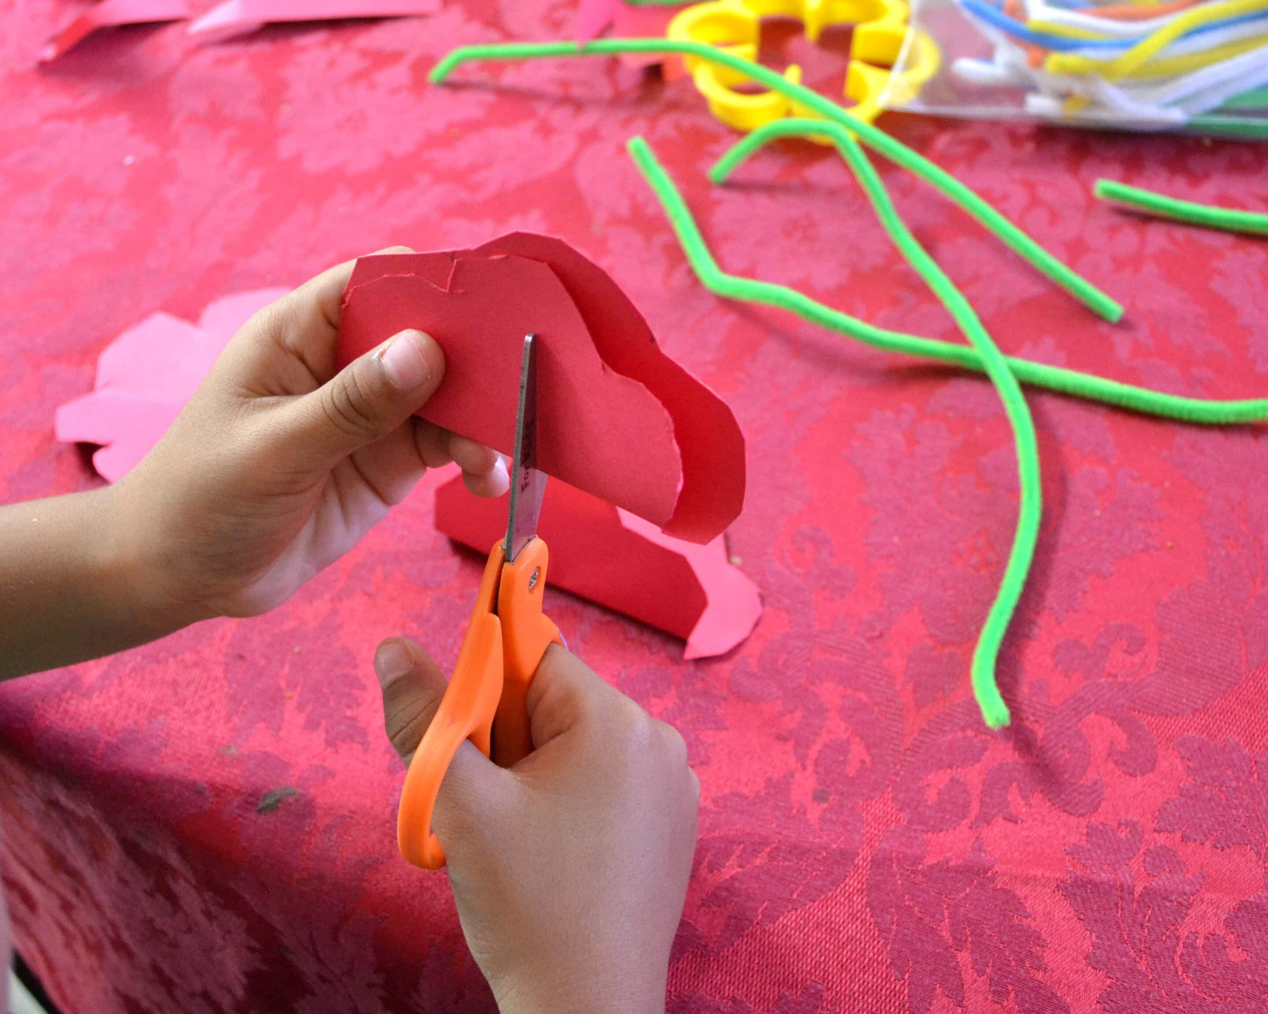

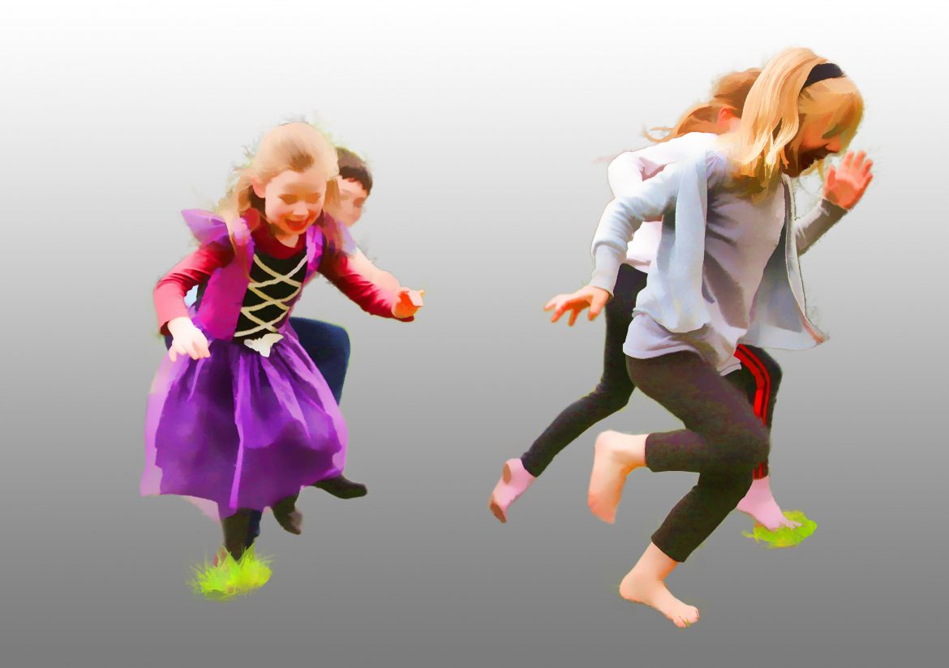



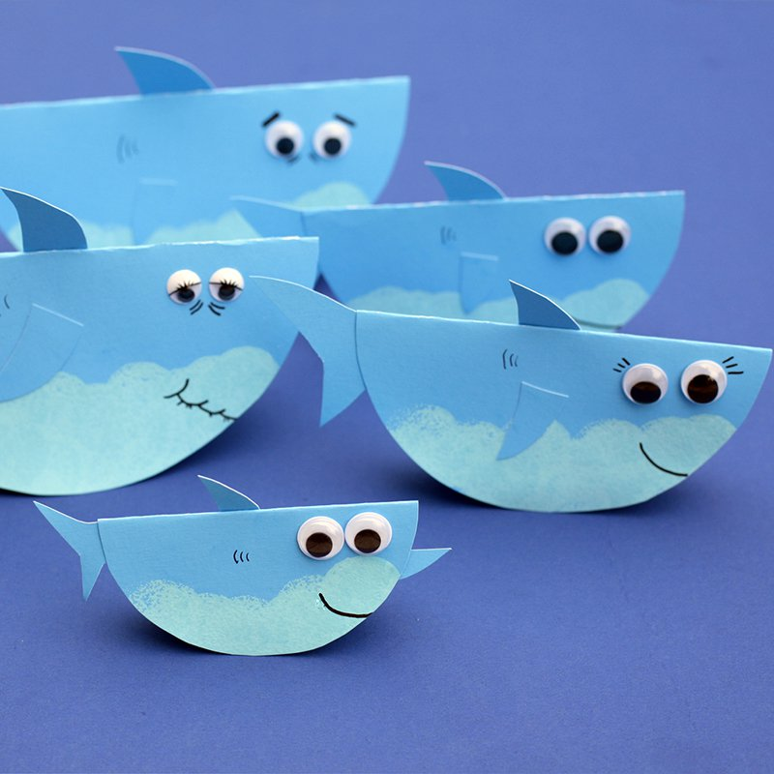







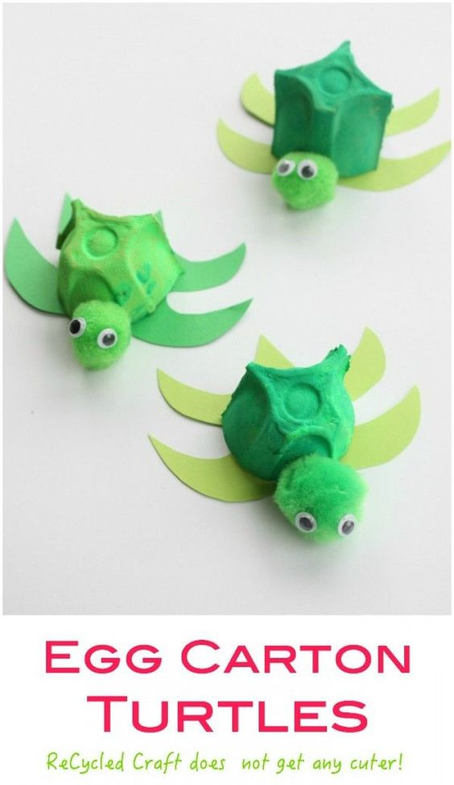





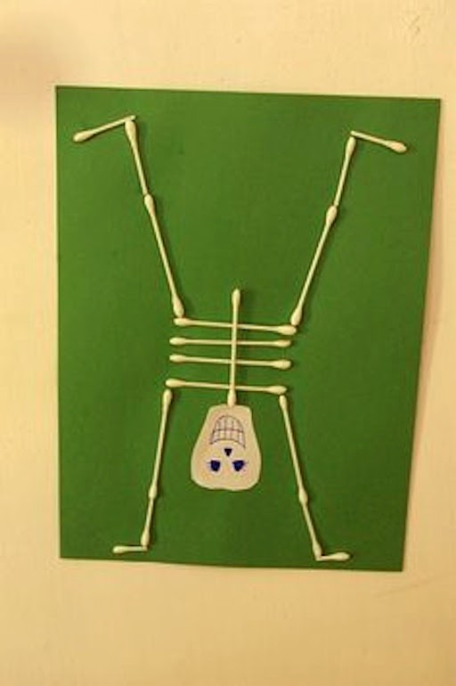

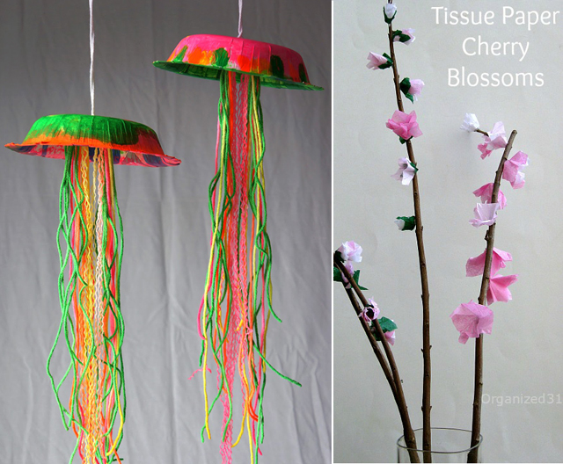



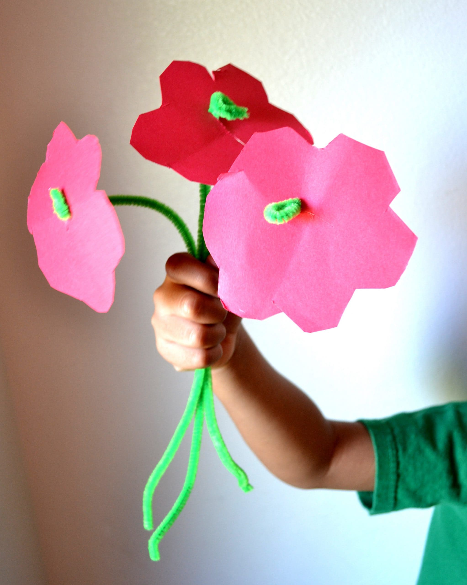

[This Photo](https://mommysnippets.com/pipe-cleaner-flower-craft/) by Unknown Author is licensed under [CC BY-NC-ND](https://creativecommons.org/licenses/by-nc-nd/3.0/)

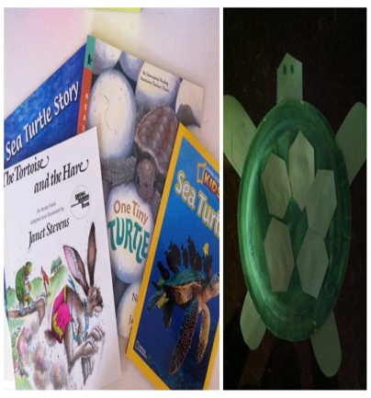

[This Photo](https://candrageorgi.blogspot.com/2011/10/t-is-for-turtle.html) by Unknown Author is licensed under [CC BY-NC-ND](https://creativecommons.org/licenses/by-nc-nd/3.0/)

SUMMER CLUB PLANNING SHEET WK BEG. 5th AUG 24

**MONDAY 5th** **TUESDAY 6th** **WEDNESDAY 7th** **THURSDAY 8th FRIDAY 9th**

MORNING MORNING MORNING MORNING MORNING

Arts & Crafts Arts & Crafts/Science Dance with Jess Arts & Crafts

Cotton Bud Skeleton Sunflower Handprint

Arts & Crafts

Stingray

Arts & Crafts

Egg Carton Turtles

Rainbow Jelly Fish

AFTERNOON AFTERNOON AFTERNOON AFTERNOON AFTERNOON

Food Preparation with Group Games in Garden Arts & Crafts Water Fun Afternoon Food Preparation

Sharon Gregory (Asda) with prizes Thumb Print Skeleton Wholewheat Pizza

Fruit Kebabs People

Arts & Crafts Arts & Crafts Arts & Crafts

Tube Flowers Pipe Cleaner Daisy Shark