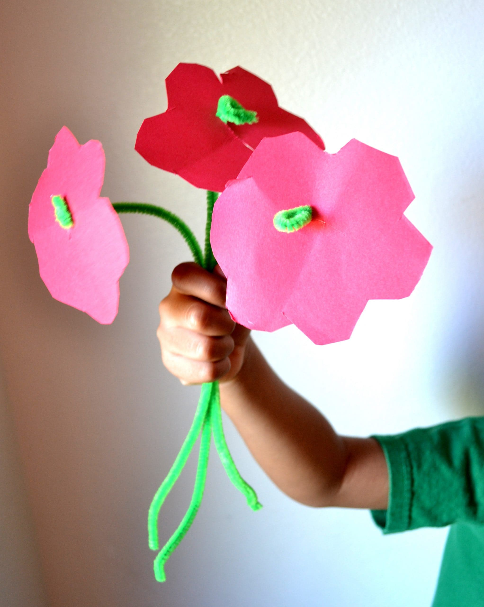



[This Photo](https://mommysnippets.com/pipe-cleaner-flower-craft/) by Unknown Author is licensed under [CC BY-NC-ND](https://creativecommons.org/licenses/by-nc-nd/3.0/)

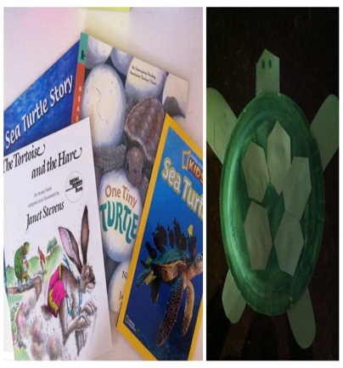

[This Photo](https://candrageorgi.blogspot.com/2011/10/t-is-for-turtle.html) by Unknown Author is licensed under [CC BY-NC-ND](https://creativecommons.org/licenses/by-nc-nd/3.0/)

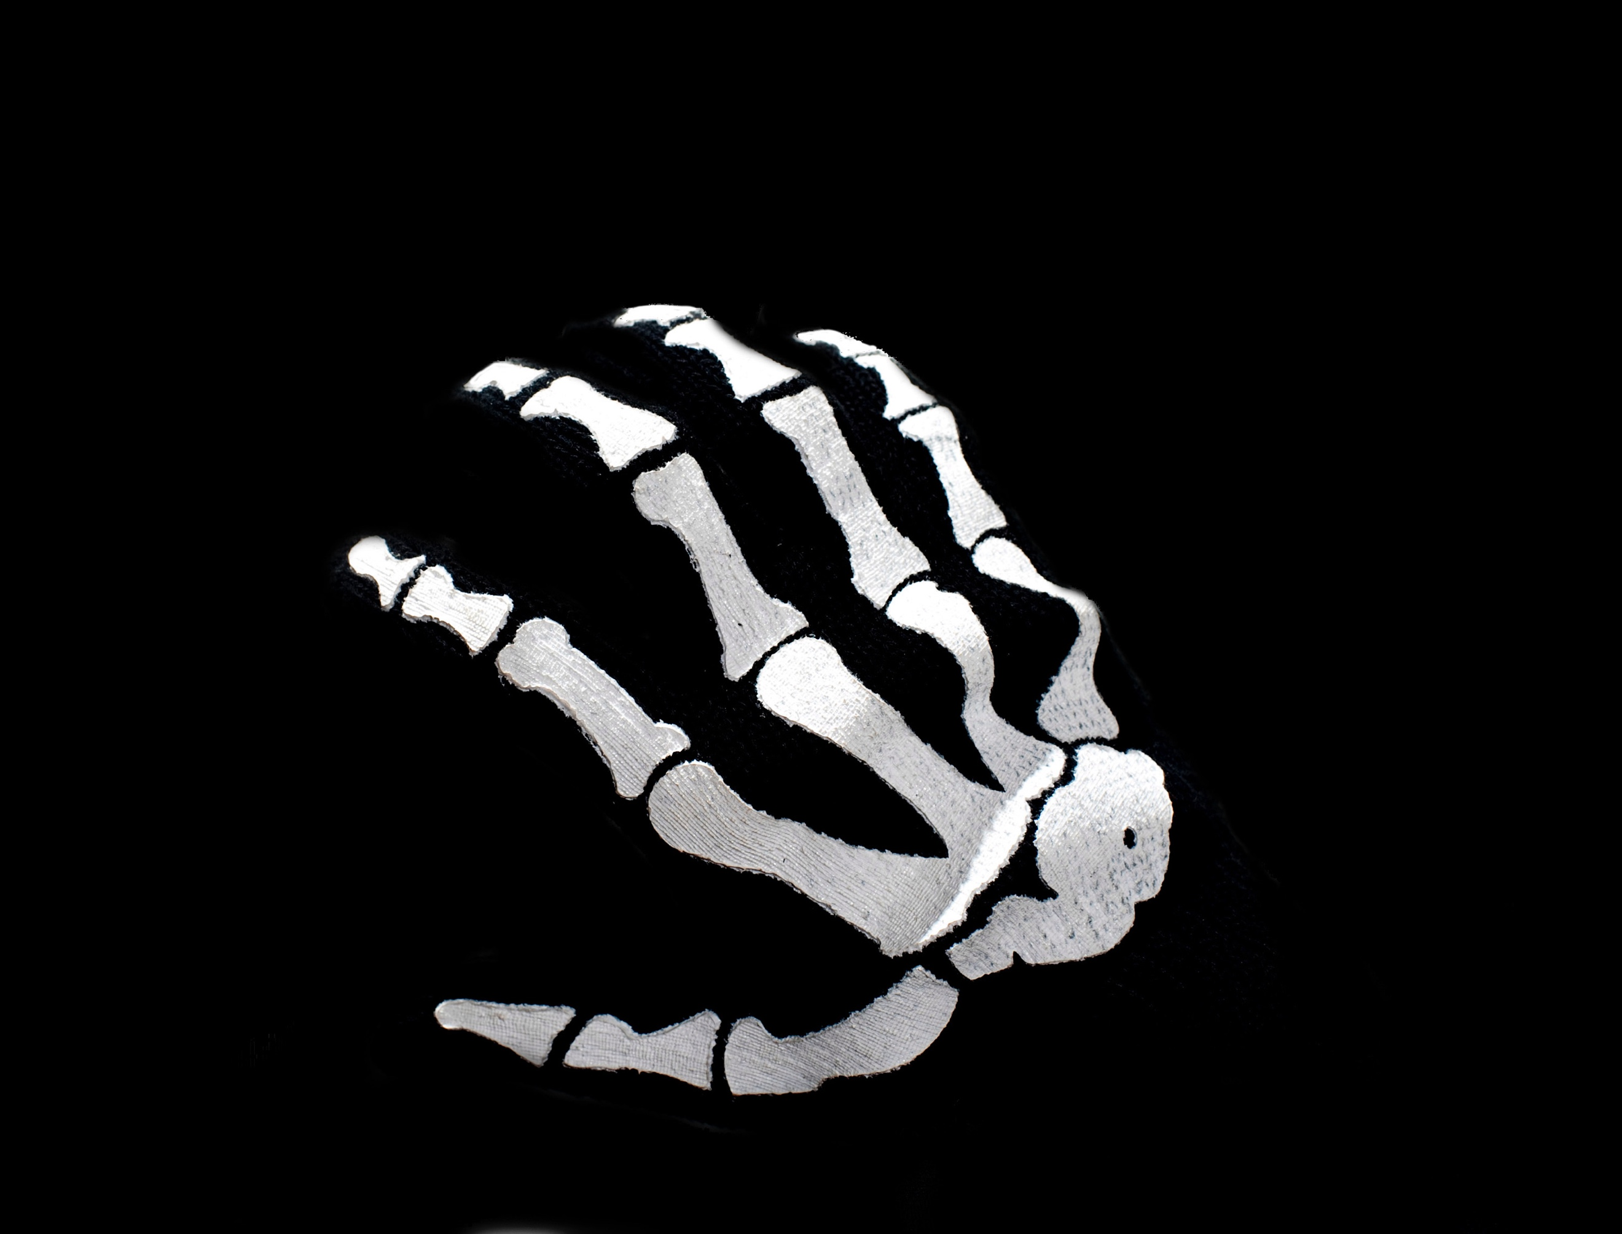

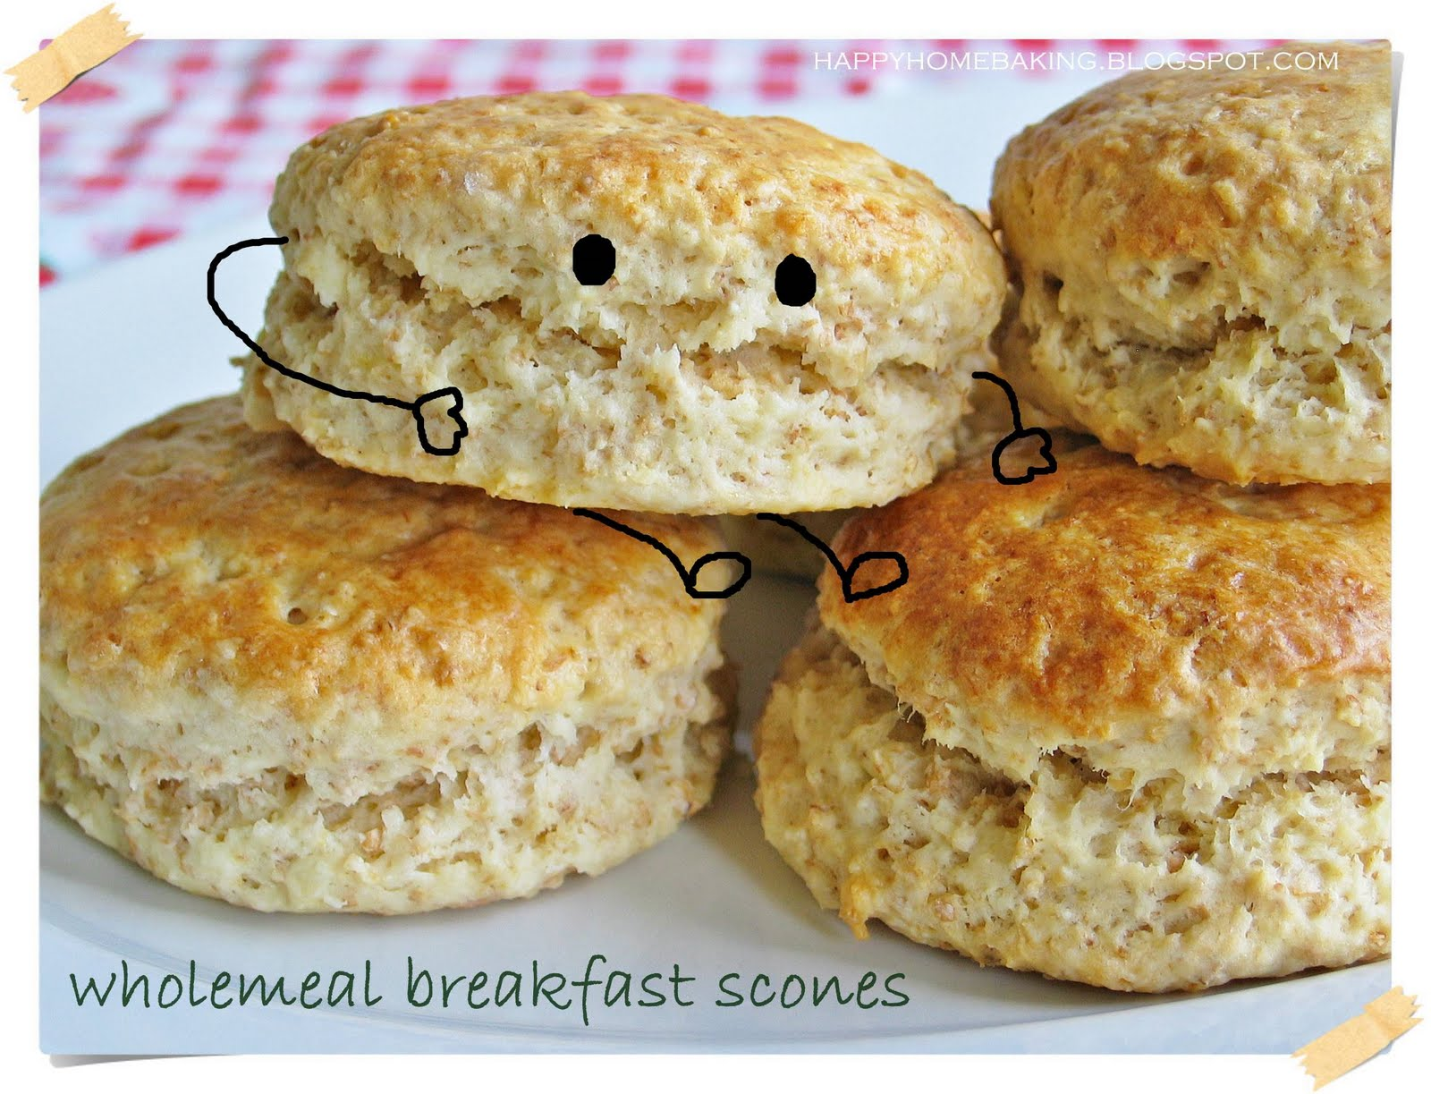

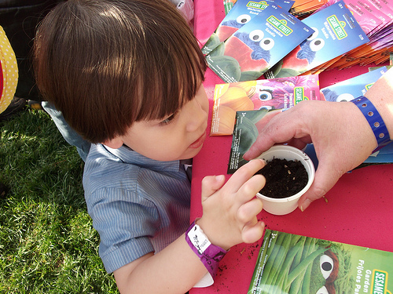



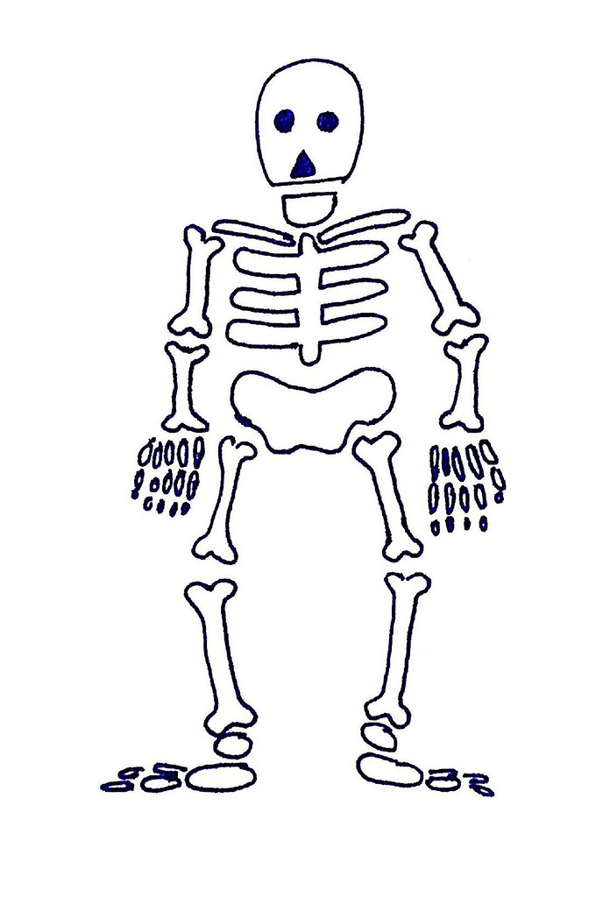

SUMMER CLUB PLANNING SHEET WK BEG. 22nd JULY 24

**MONDAY 22nd.**  **TUESDAY 23rd** **WEDNESDAY 24th** **THURSDAY 25th FRIDAY 26th**

MORNING MORNING MORNING MORNING MORNING

Arts & Crafts Arts & Crafts Baking Scones

The Human Skeleton Paper Plate Turtle

IN SCHOOL IN SCHOOL (life size)

Arts & Crafts

Skeleton Hands

AFTERNOON AFTERNOON AFTERNOON AFTERNOON AFTERNOON

Arts & Crafts Sharon Gregory from Arts & Crafts

Happy Crab Asda: Build a Flower

Planting Seeds

IN SCHOOL IN SCHOOL