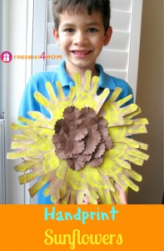

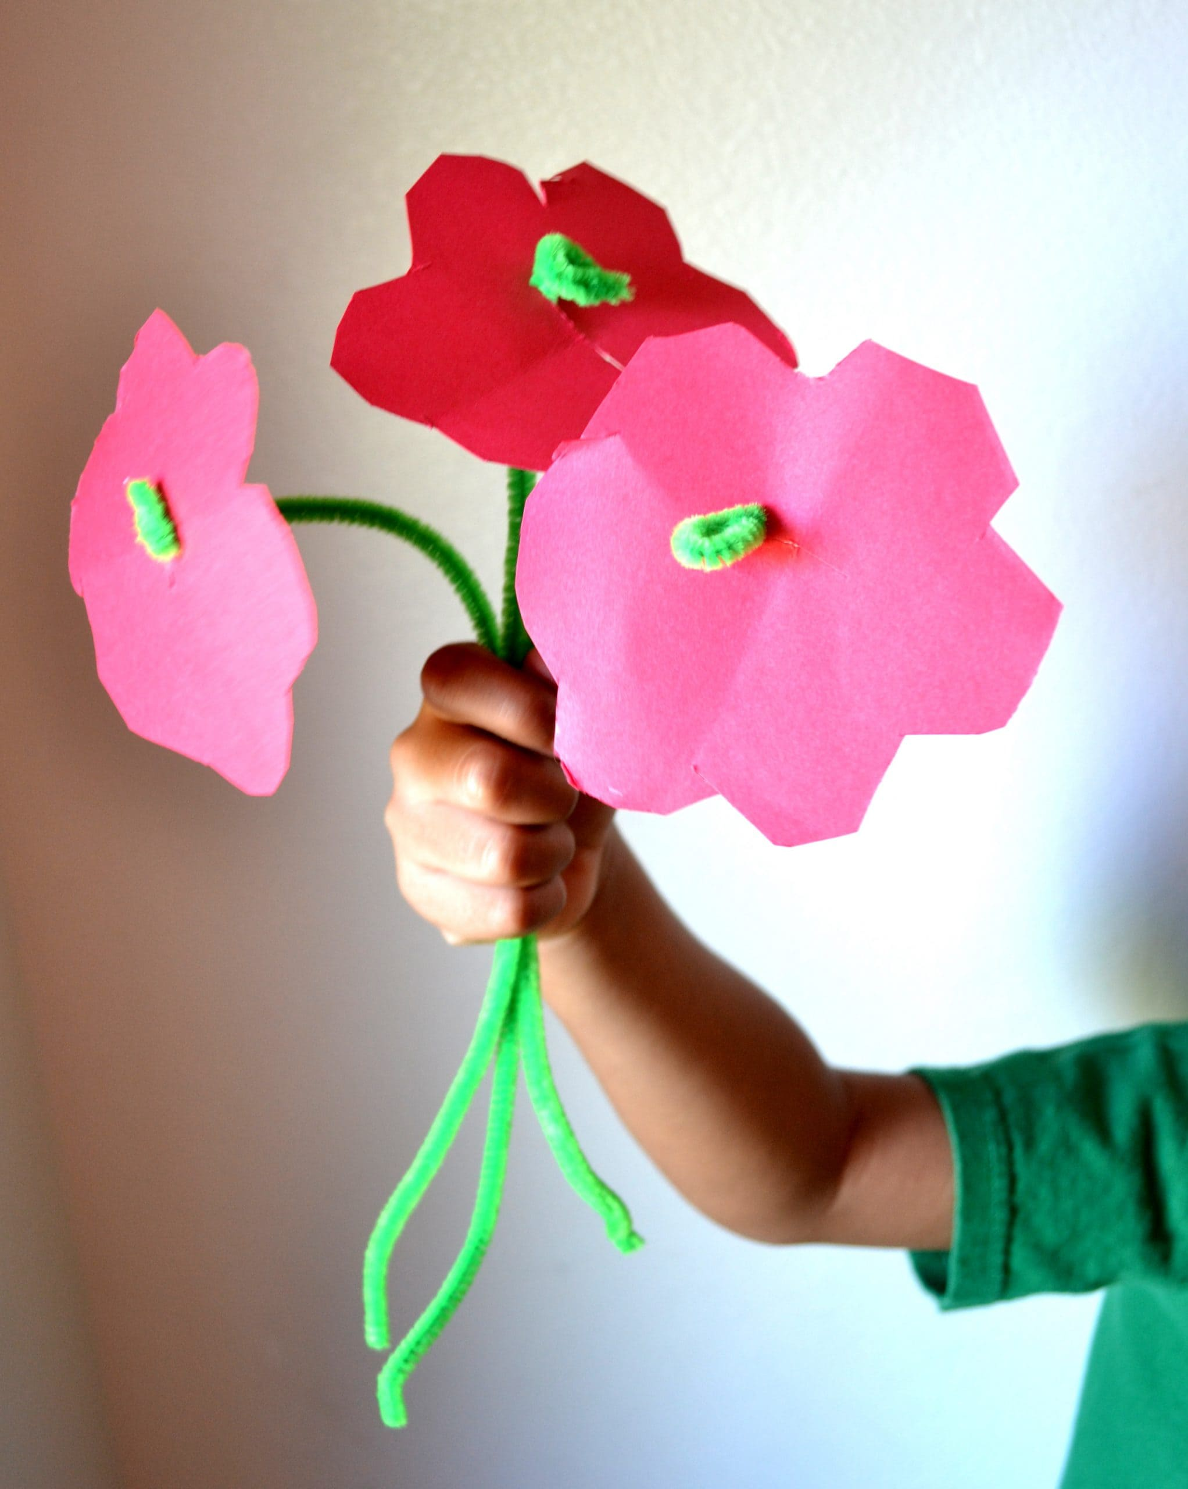

[This Photo](https://mommysnippets.com/pipe-cleaner-flower-craft/) by Unknown Author is licensed under [CC BY-NC-ND](https://creativecommons.org/licenses/by-nc-nd/3.0/)

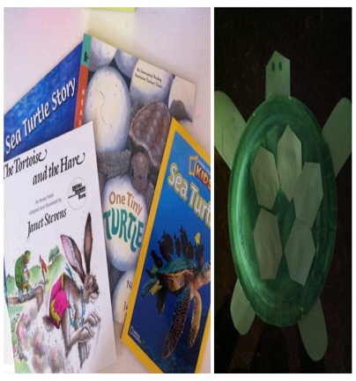

[This Photo](https://candrageorgi.blogspot.com/2011/10/t-is-for-turtle.html) by Unknown Author is licensed under [CC BY-NC-ND](https://creativecommons.org/licenses/by-nc-nd/3.0/)

SUMMER CLUB PLANNING SHEET WK BEG. 19th AUG 24

**MONDAY 19th** **TUESDAY 20th** **WEDNESDAY 21st** **THURSDAY 22nd FRIDAY 23rd** MORNING MORNING MORNING MORNING MORNING

Arts & Crafts The Atkinson Centre

Skeleton Straw Craft Museum

CLOSED CLOSED CLOSED

AFTERNOON AFTERNOON AFTERNOON AFTERNOON AFTERNOON

Dancing & Gymnastics Free Play

To Music

CLOSED CLOSED CLOSED