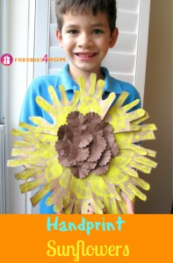



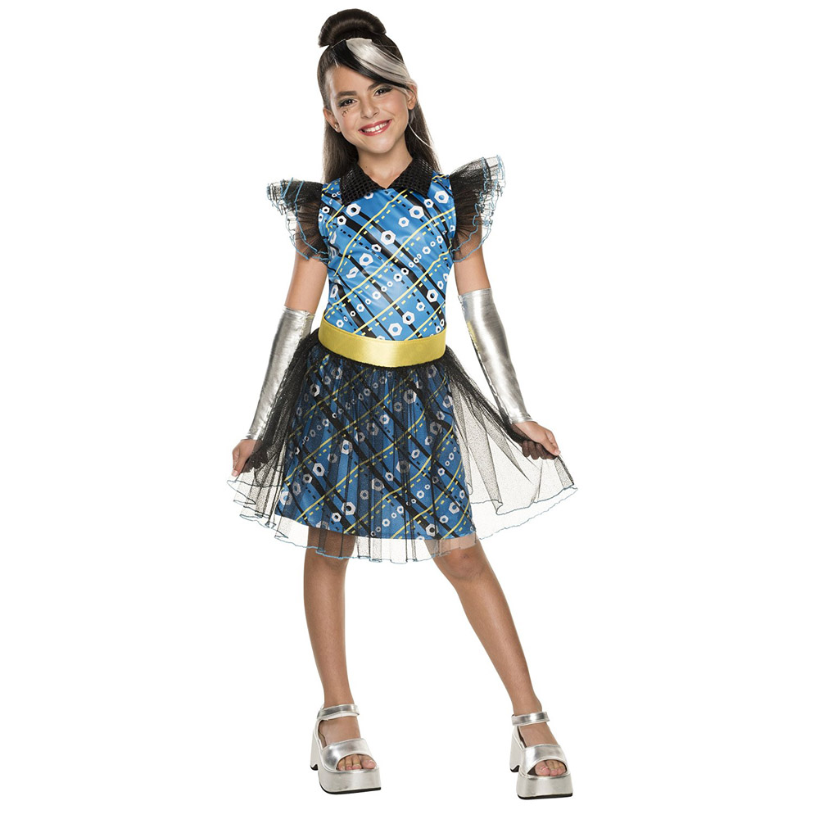

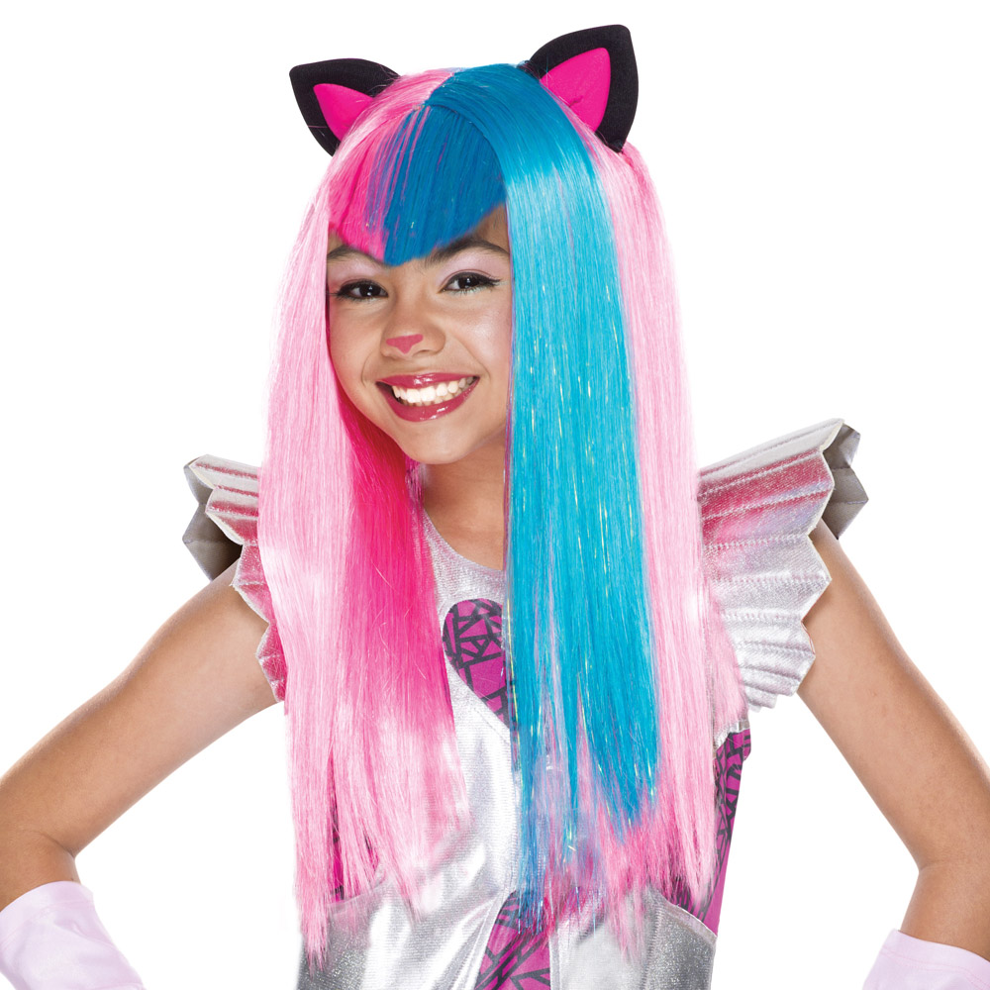

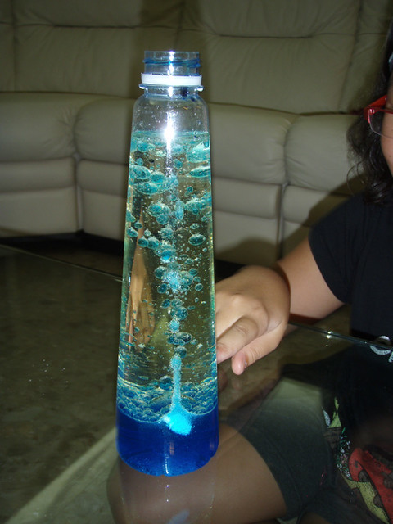



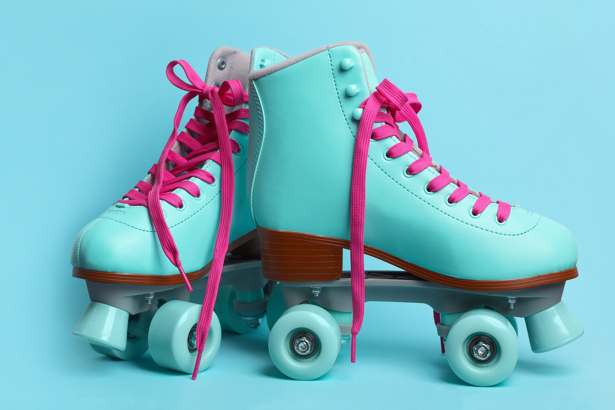

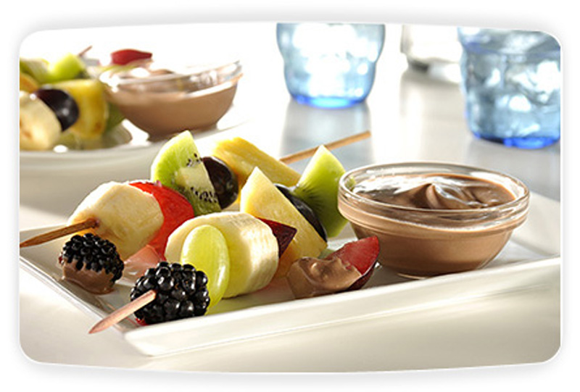



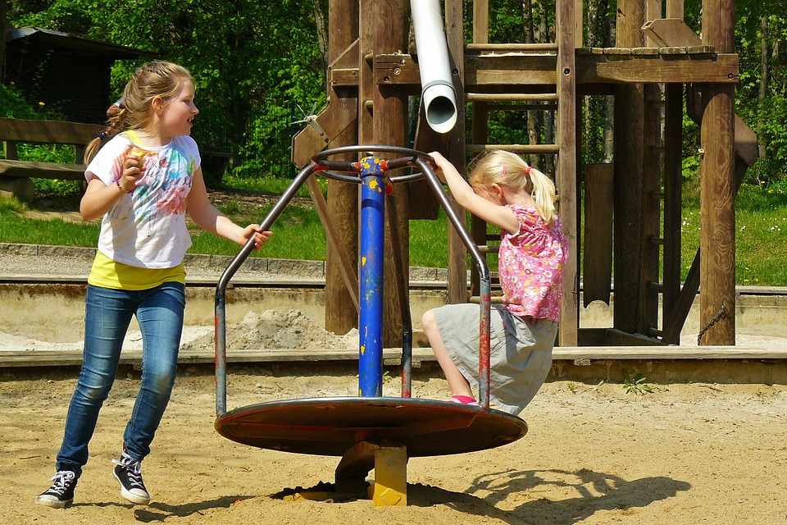

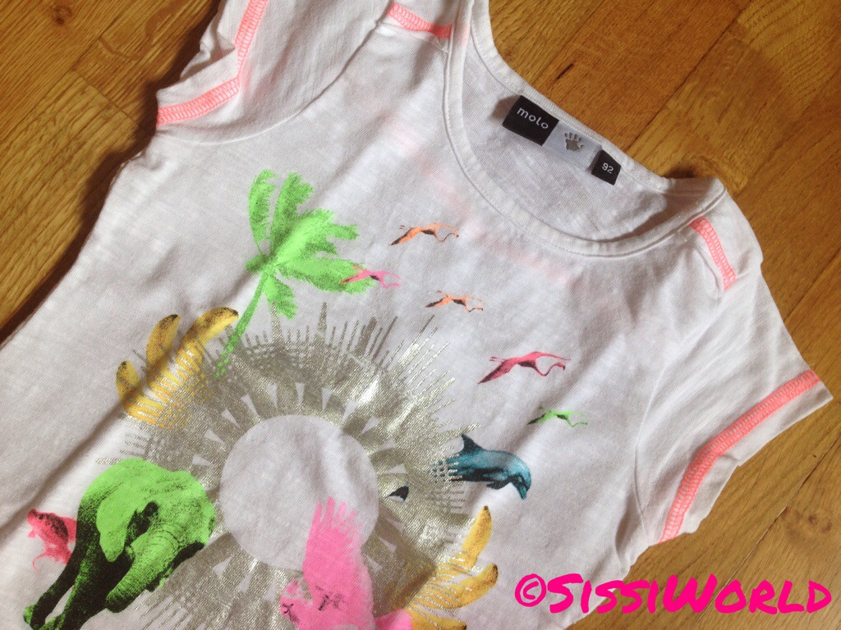

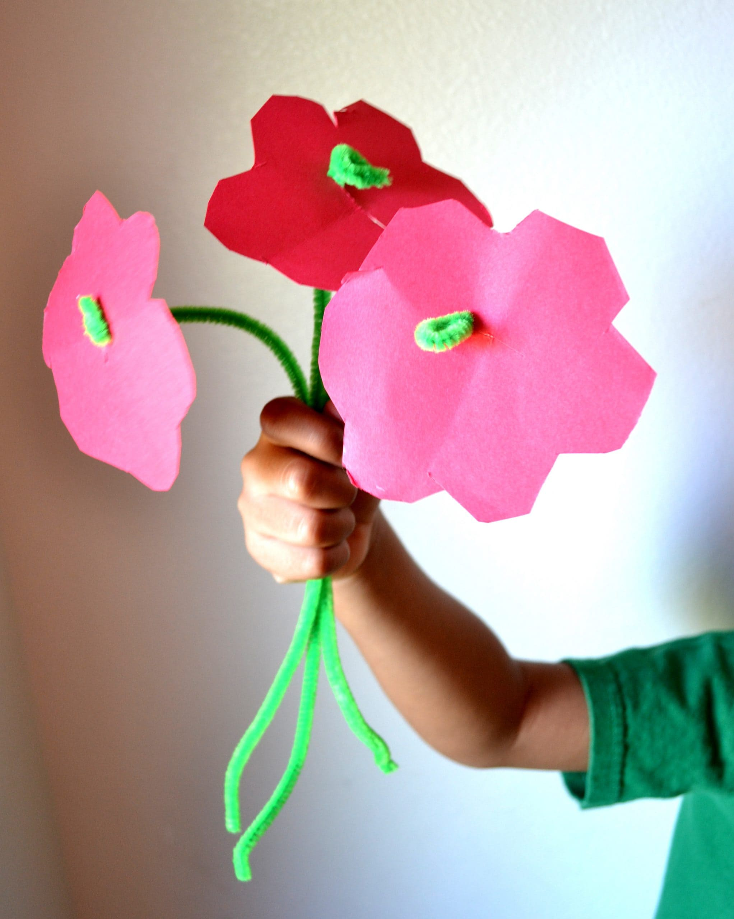

[This Photo](https://mommysnippets.com/pipe-cleaner-flower-craft/) by Unknown Author is licensed under [CC BY-NC-ND](https://creativecommons.org/licenses/by-nc-nd/3.0/)

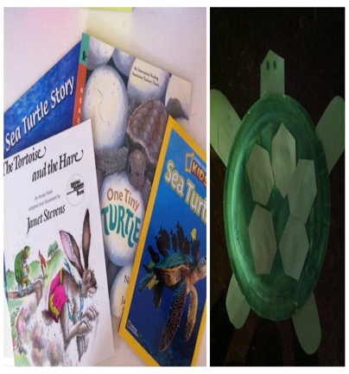

[This Photo](https://candrageorgi.blogspot.com/2011/10/t-is-for-turtle.html) by Unknown Author is licensed under [CC BY-NC-ND](https://creativecommons.org/licenses/by-nc-nd/3.0/)

SUMMER CLUB PLANNING SHEET WK BEG. 5th AUG 24

**MONDAY 5th** **TUESDAY 6th** **WEDNESDAY 7th** **THURSDAY 8th FRIDAY 9th**

MORNING MORNING MORNING MORNING MORNING

Arts & Crafts Arts & Crafts/Science Hesketh Park with Picnic Food Preparation with Arts & Crafts Lava Lamps Sharon Gregory (Asda) Finish Preparing Your

Costume

Design Your Own

Costume for a

Fashion Show

AFTERNOON AFTERNOON AFTERNOON AFTERNOON AFTERNOON

Group Games in Hall. Free Play Rollerblading at the YMCA Fashion Show with Prizes Arts & Crafts with prizes

Paper Plate Turtle

Costume Design

Tube Flowers