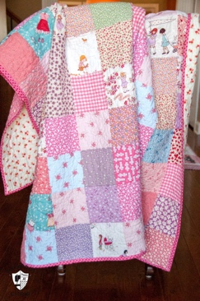

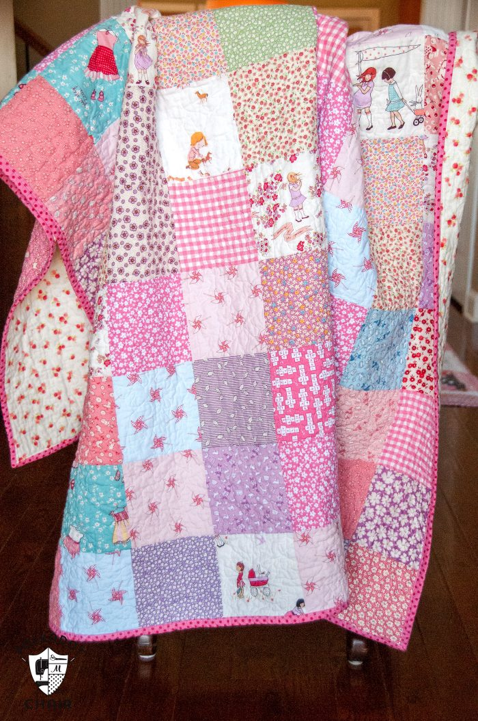



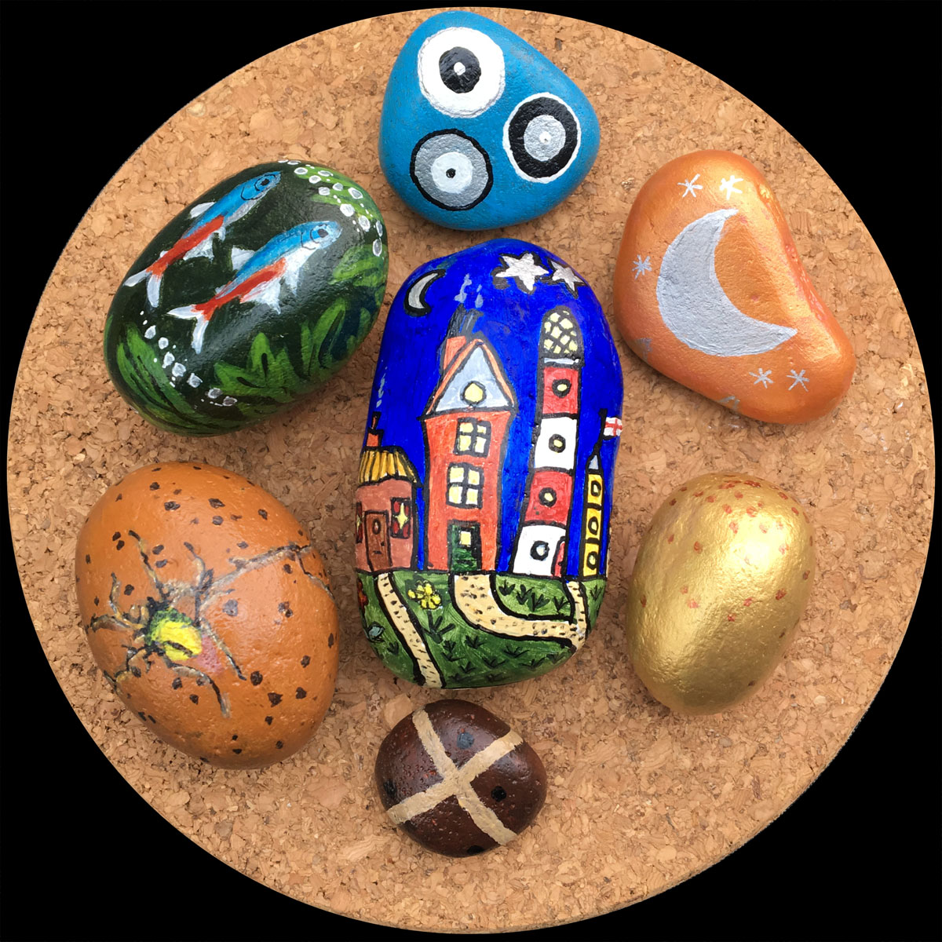

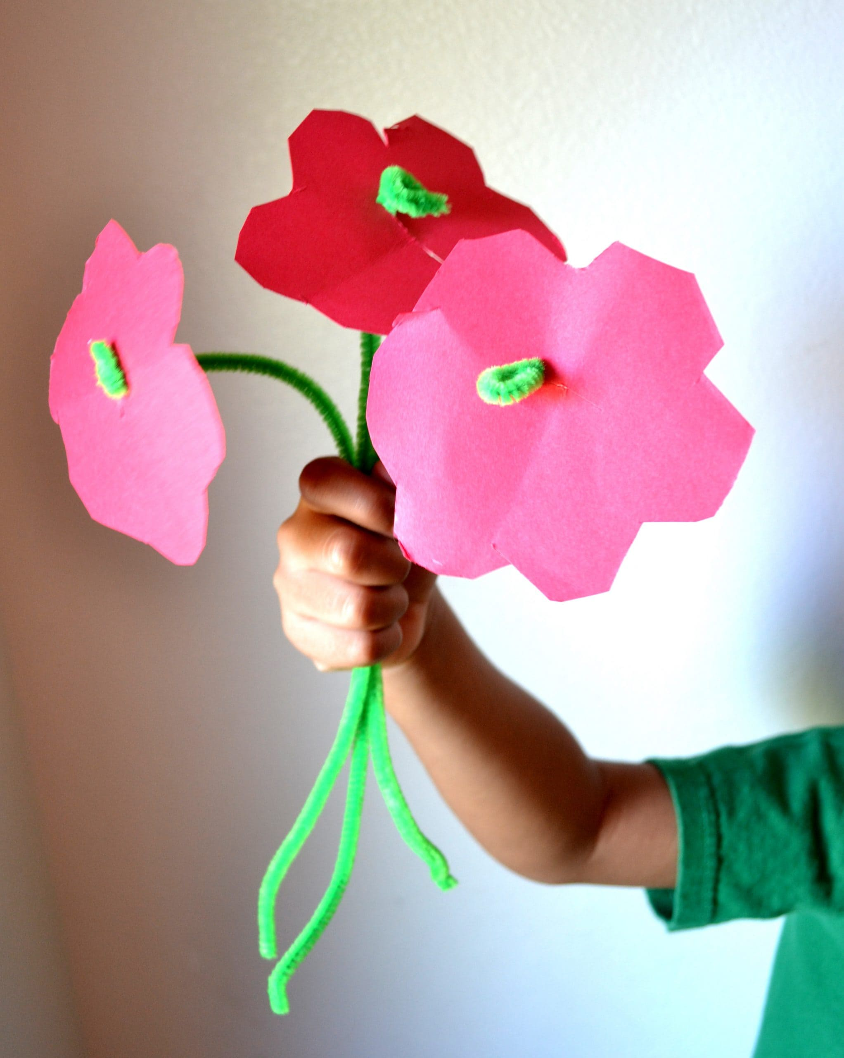

[This Photo](https://mommysnippets.com/pipe-cleaner-flower-craft/) by Unknown Author is licensed under [CC BY-NC-ND](https://creativecommons.org/licenses/by-nc-nd/3.0/)

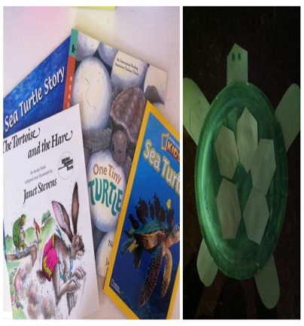

[This Photo](https://candrageorgi.blogspot.com/2011/10/t-is-for-turtle.html) by Unknown Author is licensed under [CC BY-NC-ND](https://creativecommons.org/licenses/by-nc-nd/3.0/)

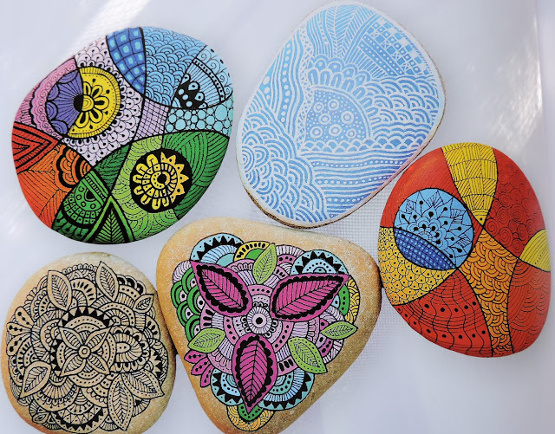

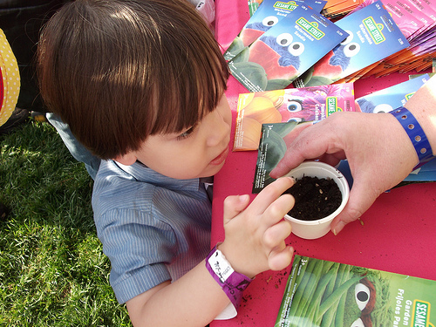

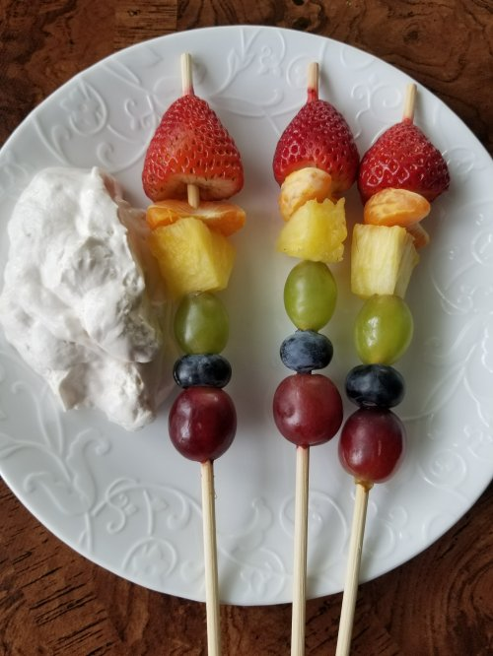

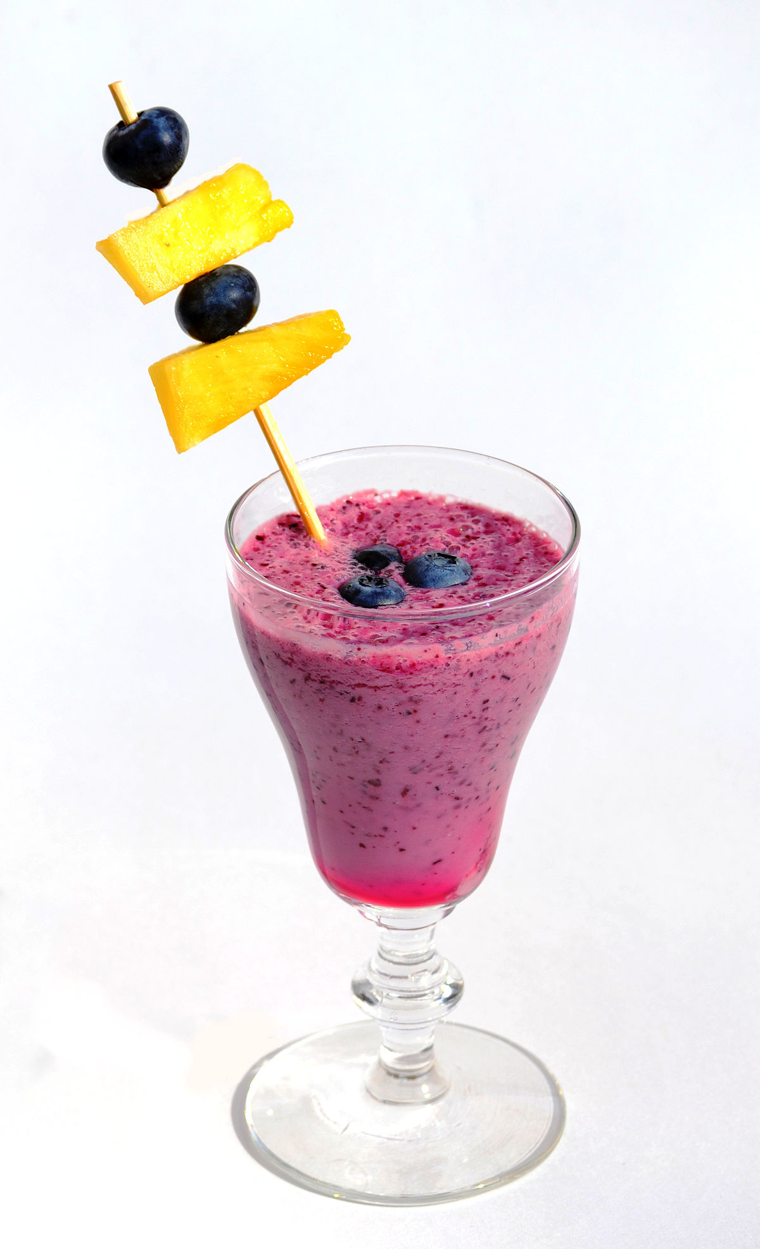

SUMMER CLUB PLANNING SHEET WK BEG. 22nd JULY 24

**MONDAY 22nd.**  **TUESDAY 23rd** **WEDNESDAY 24th** **THURSDAY 25th FRIDAY 26th**

MORNING MORNING MORNING MORNING MORNING

Arts & Crafts Sharon Gregory from Food Preparation Asda Fruity Skewer with

Stone Painting Yoghurt Dip

IN SCHOOL IN SCHOOL

Planting Seeds

AFTERNOON AFTERNOON AFTERNOON AFTERNOON AFTERNOON

Food Preparation Arts & Crafts Art & crafts

Frozen Fruit Patchworking Patchworking & Stone Smoothie Painting

IN SCHOOL IN SCHOOL